Rotary Saddle Summary of the Month

DG Deb’s letter
Page……………….………………..………………1-2
Club news
Page………….…..………….…..………..……..3-10
Membership Stats
Page……………..………..……………………11-12
Membership Growth
Page……………..….…….…..……..….….....13-14
RYLA
Page……………..……….…..……..….…...........15
President Elect Training Session
Page……………..……....……..………...........16
Rotary Graduate Scholarships
Page……………..….…….............................17
Upcoming District Conference Page……………..….………….……….….…....…18
District Govenor Nominee Page……………..….………….……….….…....…19
PolioPlus Page……………..….………….……….….…....…20


February Focus: Peace and Conflict Prevention
February is Peace and Conflict Prevention Month in Rotary — a time that reflects Rotary’s long-standing commitment to building a more peaceful world through service, dialogue, and understanding.
Now more than ever, this focus feels incredibly relevant. The world can feel unsettled. Conversations can feel tense. It seems at times that peace is harder to find. But as Rotarians, we are called to remember what February represents.
Over the past few weeks, I had the opportunity to visit few clubs across our district. In each visit, I felt something powerful — peace. I felt encouragement. I felt genuine connection. In the middle of what can feel like an unpeaceful season, I was reminded that Rotary creates spaces where understanding, service, and kindness still lead.
My personal goal as a Rotarian is simple: when someone leaves a conversation or a meeting with me, I hope they feel more at peace and less in conflict than when they arrived.
These past couple of months have felt unsettling for me and my family at times. Yet the fellowship and support I experienced with fellow Rotarians this February was peaceful, grounding, and encouraging. It reminded me of why we do what we do.
Peace doesn’t always start globally. Often, it begins at a table, in a meeting, in a service project, or in a simple act of listening. As members of Rotary International and leaders within Rotary District 5680, we have the opportunity — and the responsibility — to be that steady presence.
Let’s continue to create peace in our clubs, our communities, and in our everyday interactions. Unite for Good. Lead with understanding. Choose peace.

Deb Minkler –
District Governor 2025-2026
Rotary District 5680
Atwood, KS Club

Club News from District 5680
Rotary Club of West Wichita had a great time handing out bookshelves to the first graders at Benton and Lawrence Elementary Schools last week. A special thank-you to Project Chairs Vern Klassen and John Mosley; to Bob Broeckelman for his additional help; to Jodi Barnwell for coordinating with the schools and providing workspace; to Star Lumber for supplying the materials; and to Roger Bowles for the stickers. And, of course, a big thank-you to ALL who helped make this project a success!
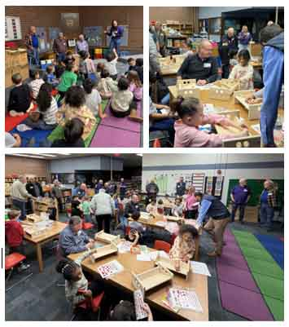
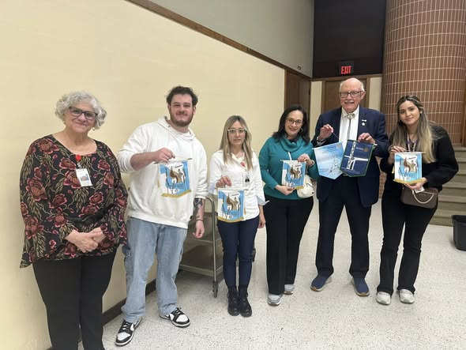
The Rotary Club of East Wichita met with RITE (Rotary Inter-Country Teacher Exchange) teachers visiting and working with our members to assemble 100 “Birthday Party in a Box” kits. These kits went to Salvation Army for distribution to needy families.
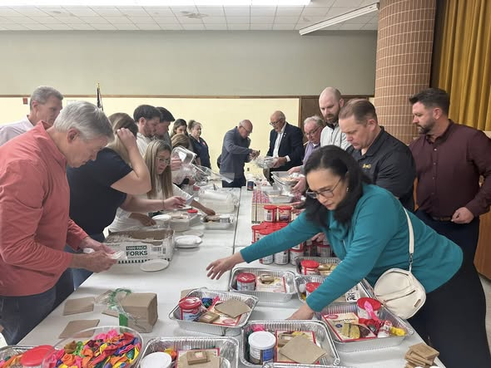
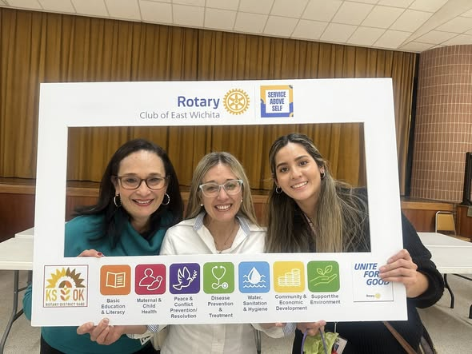
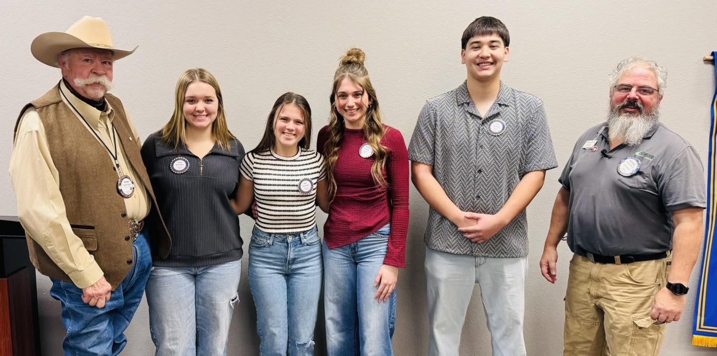
The Rotary Club of Great Bend introduces our exceptional Junior Rotarians for February. They are from left Shelby Steffan, Heidi Jording, Katherine Mazouch, and Eli Contreras. Not pictured is Phoebe Sperlein. They are pictured here with our club president-elect Taylor, Smith, and their sponsor Rotarian Michael Mayhill. These outstanding young people are now eligible to apply for a junior Rotarian scholarship.

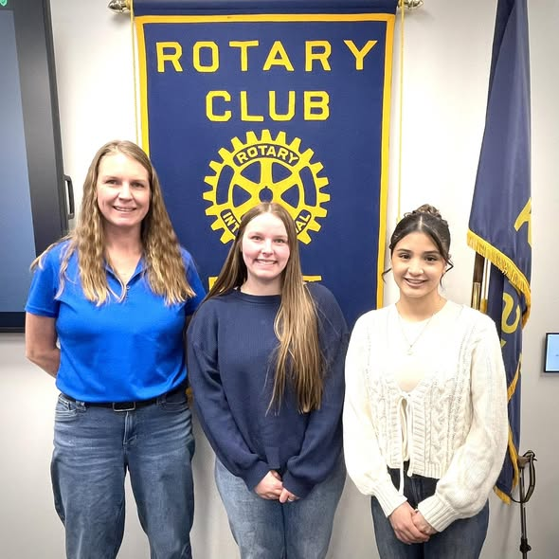
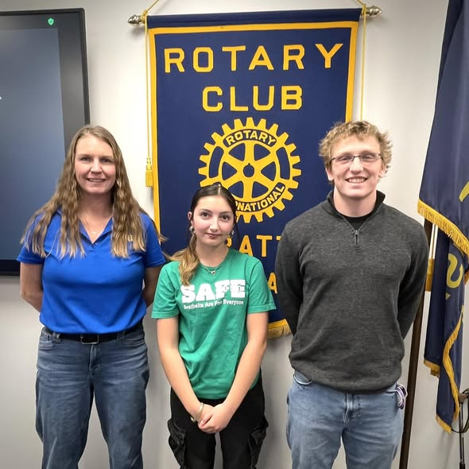
The Rotary Club of Pratt welcomed four students and recognized them as “students of the month”. From Skyline High School were Sarah Reyes and Peyton WalkerVisiting from Pratt High School, Luke Gatlin and Kaitlyn Vega

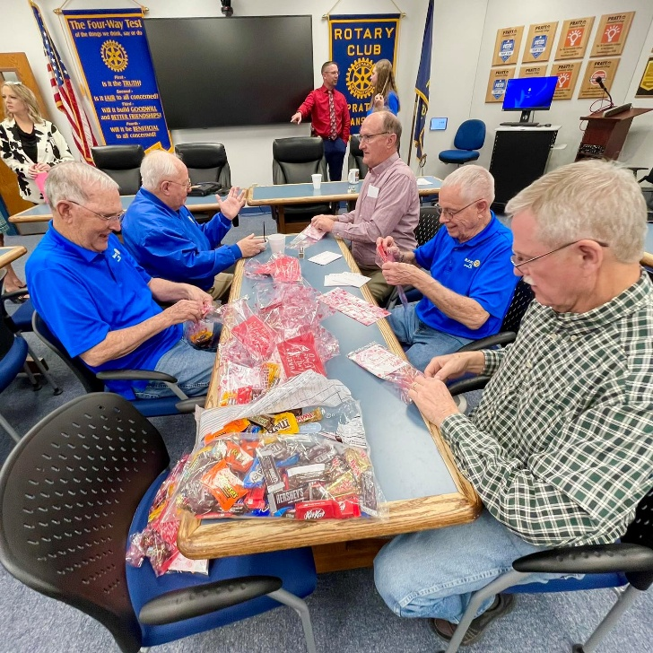

The Rotary Club of Pratt stayed after a meeting to fill candy bags, this month’s Service Project. The candy bags are being taken to the Parkwood Village residents for Valentine’s Day.

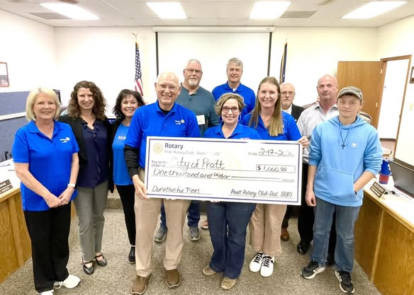
Rotary Club of Pratt President Amy Prater and Service Committee Chair Suzan Patton addressed the City Commissioners, sharing that several Rotary club members were in attendance to present a community service donation check for $1,000.

The Rotary Club of Washington held a first time fund raising event on Valentine’s Day. The event featured a prime rib dinner, dessert bar and open bar. Entertainment showcased dueling pianos and audience participation. Besides ticket prices, the Festival included both silent and regular auction items donated by community members and Rotarians. Proceeds will be used to refurbish the pavilion at the Rotary build pickleball court & fairgrounds. The event, which replaced the long time Festival of Trees, raised a RECORD amount for the pavilion and club projects.
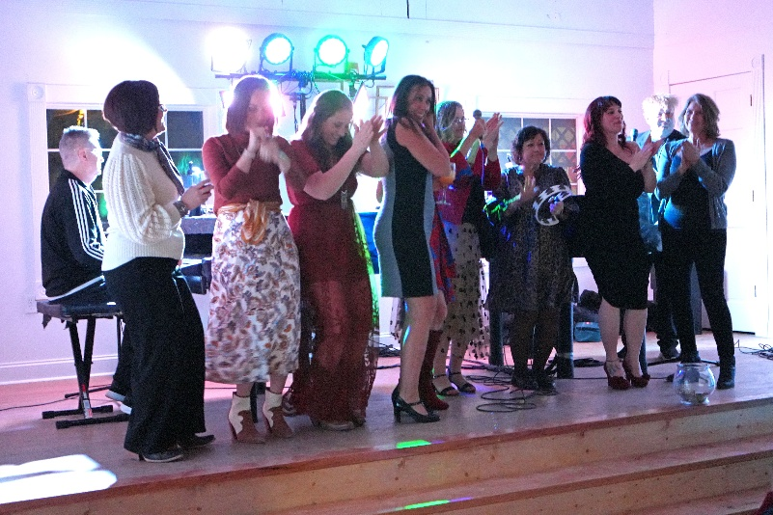
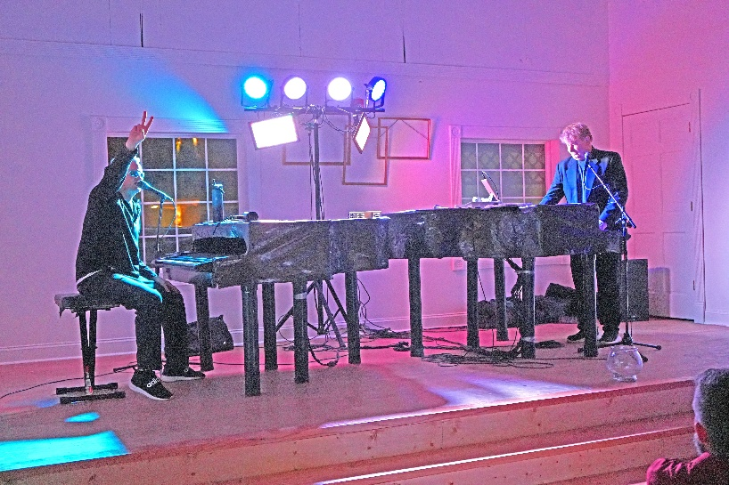
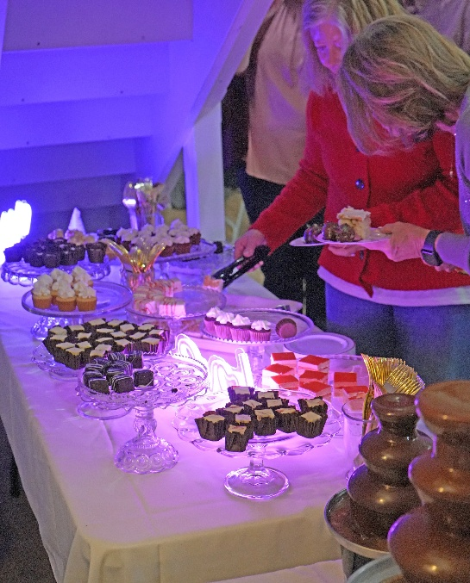
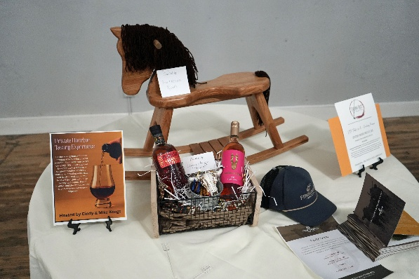
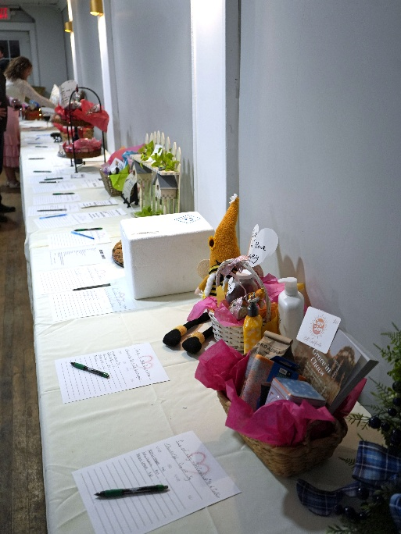
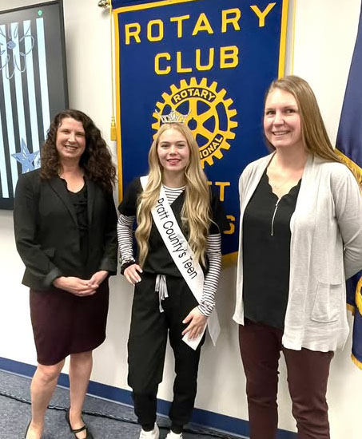

Sydney Riley, Miss Pratt County’s Teen, spoke to the Rotary Club of Pratt. Sydney is a senior at Pratt High School, where she is a three-sport athlete. She plans to attend MidAmerica Nazarene University in Olathe next year and graduate with a Bachelor of Science in Nursing.
Her goal is to apply to CRNA school at the University of Kansas upon completion of a BSN.

PDG and Rotary Club of Liberal member Ivanhoe Love Jr. asked each of their members to donate a minimum of $50 per member to the Liberal Fire Relief fund by March 31st. This effort will support the 12 volunteer fire departments that were involved with these wildfires last week. Money may be sent to D5680 Treasurer Kent Erb at 921 W. 17th St., Newton, KS 67114, using the link or QR code below. Clubs are encouraged to consider donations as well. We are pleased to let you know that the Liberal Rotary Club and District 5680 have each made a $1,000 donation to support the efforts. Please consider making your donation by March 31st. Thanks for any help you can give.


https://square.link/u/uvXBKc3n

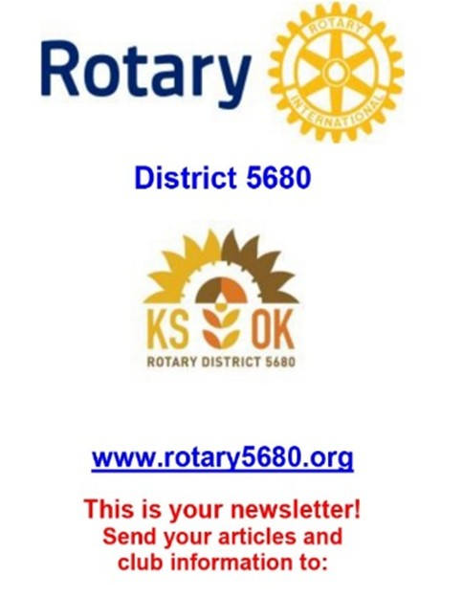
Larry D. Stoppel, O.D.
District Newsletter Editor

ldstoppel@ gmail.com

Cell phone

785-747-8526

Send me your news and newsletters!

District 5680 Membership Report As of February 28, 2026
Club | 7/1/2025 | 2/28/2026 | NET GAIN
 | MEMBERSHIP | MEMBERSHIP | 2025-2026
Abilene | 53 | 50 | (3)
Andover | 18 | 20 | 2
Arkansas City | 68 | 62 | (6)
Atwood | 24 | 24 | 0
Beaver | 16 | 16 | 0
Beloit | 30 | 30 | 0
Boise City | 22 | 23 | 1
Cimarron | 17 | 17 | 0
Clay Center | 64 | 60 | (4)
Colby | 35 | 35 | 0
Concordia | 26 | 19 | (7)
Derby | 55 | 54 | (1)
Dodge City | 30 | 33 | 3
Downs | 7 | 0 | (7)
East Wichita | 67 | 62 | (5)
E-Club | 16 | 17 | 1
El Dorado | 31 | 30 | (1)
Ellinwood | 13 | 13 | 0
Ellis | 10 | 9 | (1)
Garden City | 22 | 19 | (3)
Goodland | 13 | 14 | 1
Great Bend | 28 | 26 | (2)
Guymon | 23 | 26 | 3
Haskell County (Sublette) | 16 | 17 | 1
Hays | 52 | 50 | (2)
Hays Sunrise | 12 | 8 | (4)
Hill City | 7 | 9 | 2
Howard | 10 | 10 | 0
Hugoton | 13 | 11 | (2)
Hutchinson | 86 | 83 | (3)
Kingman | 21 | 19 | (2)
Kinsley | 5 | 4 | (1)
Liberal | 32 | 32 | 0
Lyons | 21 | 20 | (1)
McPherson | 27 | 25 | (2)
Ness City | 21 | 21 | 0
Newton | 55 | 57 | 2
Norton | 11 | 8 | (3)
Oberlin | 29 | 29 | 0
Osborne | 9 | 8 | (1)
Phillipsburg | 44 | 37 | (7)
Pratt | 72 | 62 | (10)
Russell | 39 | 35 | (4)
Salina | 96 | 89 | (7)
Sterling | 13 | 12 | (1)
Syracuse | 18 | 15 | (3)
Texhoma | 8 | 9 | 1
Ulysses | 16 | 18 | 2
Washington | 31 | 29 | (2)
West Sedgwick Co Sunrise | 36 | 38 | 2
West Wichita | 70 | 79 | 9
Wichita-Downtown | 347 | 354 | 7
Wichita-Old Town | 8 | 8 | 0
Winfield | 60 | 57 | (3)
TOTALS | 1973 | 1912 | (61)
Larry D. Stoppel, O.D.
District Newsletter Editor

ldstoppel@ gmail.com

Cell phone

785-747-8526

Send me your news and newsletters!

From the District Membership Chair: Growing Rotary—Together
Hello Rotarians,
Alana McNary
District Membership Chair

Rotary has always been about people—people coming together to serve, to lead, and to make a difference in their communities. As your District Membership Chair, my focus this year is on partnering with clubs and their local membership teams to ensure our clubs remain vibrant, welcoming, and reflective of the communities we serve.
This year, Rotary International continues to emphasize membership growth through strong club experiences, and that work starts with belonging. Before we ask people to stay, to lead, or to invite others, we have to be intentional about how it feels to be part of our clubs.

This Month’s Membership Focus: Belonging Club Culture
A welcoming club culture doesn’t happen by accident—it’s created through small, consistent actions. Simple things like greeting members by name, intentionally including new voices in conversations, and making sure no one feels like an outsider go a long way in strengthening connection. Belonging is often the deciding factor in whether a new member stays past their first year.
This month, I encourage clubs to look at their culture through a fresh lens. Ask yourselves: How do we welcome new members? Who makes sure they’re connected beyond meetings? Are we creating space for different perspectives and experiences? When members feel seen and valued, engagement and retention naturally follow.

Across Rotary, strong club culture is recognized as a foundation for long-term membership success. By focusing on belonging first, we create clubs where people want to stay—and where they’re proud to invite others.
If your club would like ideas, tools, or a sounding board as you work on strengthening culture and connection, I’d love to support you. Please feel free to reach out to me directly at alana.mcnary@pec1.com.
Thank you for all you do for Rotary and your communities. I look forward to partnering with you as we grow membership and strengthen our clubs—together.
Try This This Month:
Assign one member at each meeting to intentionally welcome guests and help new or quieter members feel included.
In Rotary Service,
Alana McNary
District Membership Chair 316-518-0732

Register today for RYLA. Every Rotary Club is encouraged to send at least two students. Scholarships available. www.sckans.edu/leadership
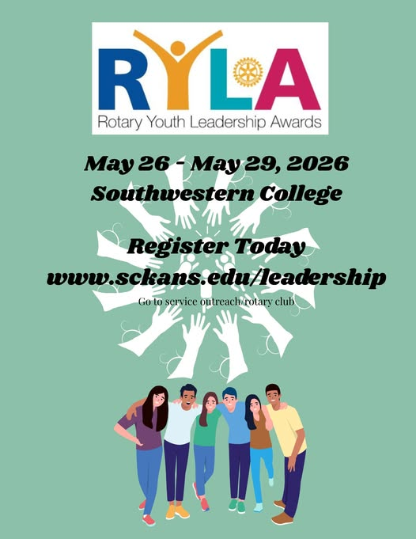

Exciting things happening at PELS!! Register Today! https://rotary5680.org/event/heartland-pels-2026/


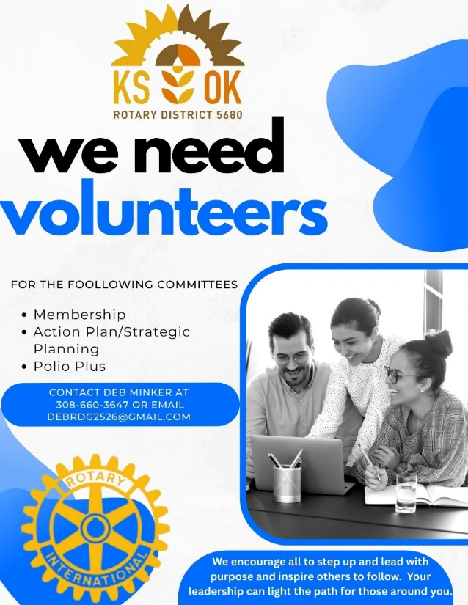


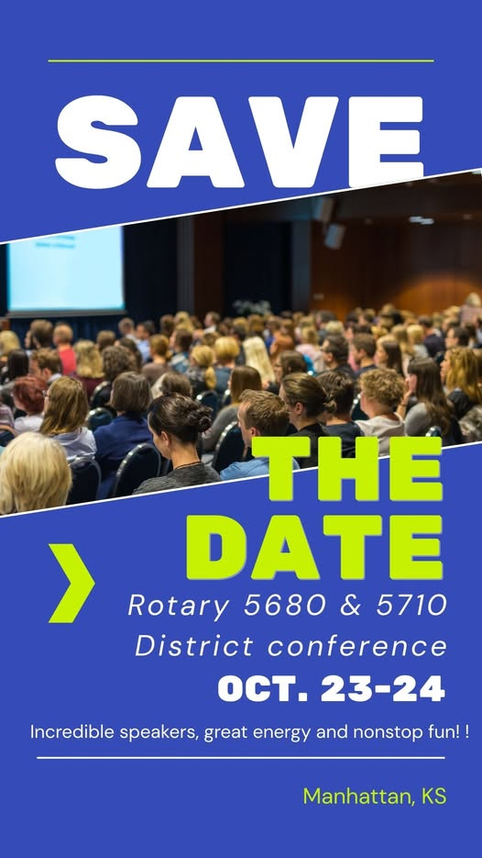
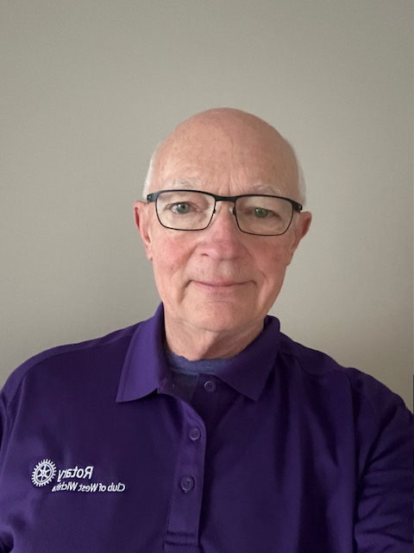
Rotary District 5680 District Governor Nominee
Ed Frey has been a member of the Rotary Club of West Wichita since 2022 and currently serves on the Board of Directors as Immediate Past President and as Rotary District 5680 Learning Facilitator. During his year as President, the club was recognized as Rotary District 5680 Club of the year and Ed was recognized as Rotary District 5680 Club President of the Year.
Ed has been active in his club serving on the International Committee helping plan, host and facilitate for the Open World Program and the Rotary Intercountry Teacher Exchange. He also traveled to Tanzania with DGE Isaac McNary to assist in installing filtration systems that the West Wichita club helped finance. Ed has also been an active supporter of Shelter Box and served as a Shelter Box Ambassador for the District. He also participates in and assists with various club projects and is active in planning and assisting with the club’s annual fundraising gala. In addition to Rotary, Ed is active in his church and currently serves on the Board of the K-State Alumni Association.
He is married to BJ Wells, and they have three adult children and six grandchildren. Ed and BJ enjoy spending time with family, outdoor activities, traveling and attending K-State games and activities. Last year Ed joined the Seven Continent Club after he and BJ went on a trip to Antarctica, his last continent to explore.
Ed is excited to begin his District Governor preparation. “I’m honored and humbled to be selected as Rotary District 5680 District Governor Nominee and look forward to serving our District and building on the legacy established by those who have served before me.”

Why Polio Plus?
This weekend I had the honor of joining several hundred Rotarians from across Mexico at their RIMEX conference. While I was there, I met several Rotarians, some not much older than myself, who had survived Polio and are still dealing with the symptoms of a disease that once terrorized the world. It drove home to me just how close Polio still is to us, and the impact that Rotary’s efforts to end Polio have had on the world!
When I slow down and actually think about Rotary’s Polio Plus initiative, there is only one word that comes to mind. Audacity. The sheer audacity that our organization had to believe that we can eradicate a disease from the earth. I love Big Hairy Audacious Goals (BHAGs), they push us and stretch us, and they make us better through the process. Ending Polio has made us a better organization and when we cross that finish line, the worldwide celebration is going to be truly unbelievable! Join us as we push forward with audacity and end polio forever!!!

Yours in Rotary Service,
Isaac McNary
The Kilt Guy - (316)-461-0512

District 5680 - KS/OK
District Governor Nominee
Assistant Governor
Chair - Polio Plus
Visioning Facilitator
